**Step1: Download selenium grid:**

<https://www.selenium.dev/downloads/>

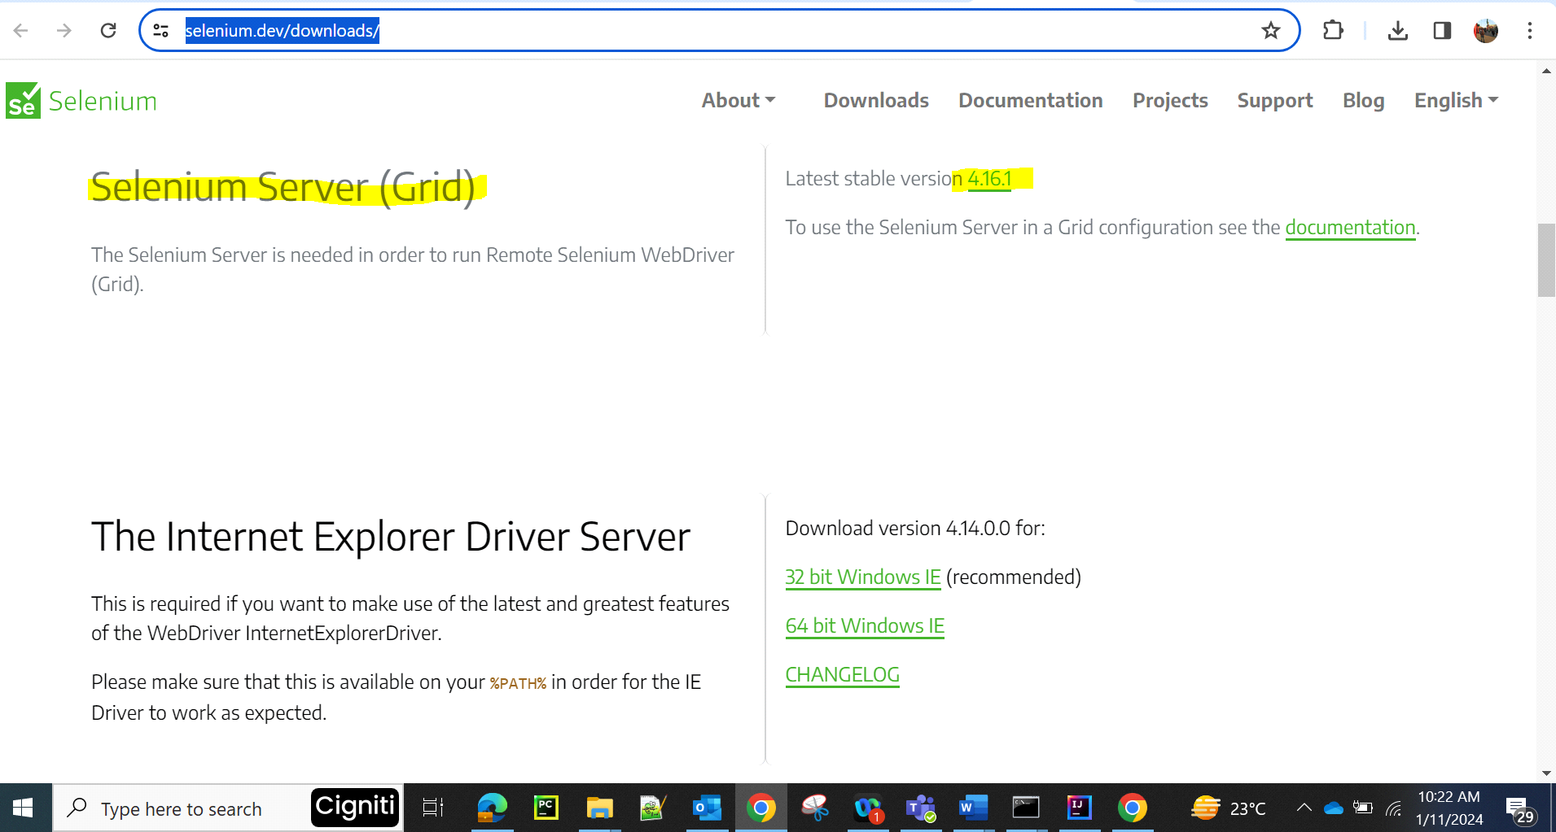

**Step2: Start selenium grid and register (hub-MasterNode-MasterMachine):**

C:\Users\xxxxxxx\Downloads\SeleniumGrid>java -jar selenium-server-4.16.1.jar hub

C:\Users\venkat.kamani\Downloads\testAutomation>java -jar selenium-server-4.17.0.jar hub

09:15:05.567 INFO [LoggingOptions.configureLogEncoding] - Using the system default encoding

09:15:05.567 INFO [OpenTelemetryTracer.createTracer] - Using OpenTelemetry for tracing

09:15:06.011 INFO [BoundZmqEventBus.<init>] - XPUB binding to [binding to tcp://*:4442, advertising as tcp://192.168.0.103:4442], XSUB binding to [binding to tcp://*:4443, advertising as tcp://192.168.0.103:4443]

09:15:06.105 INFO [UnboundZmqEventBus.<init>] - Connecting to tcp://192.168.0.103:4442 and tcp://192.168.0.103:4443

09:15:06.154 INFO [UnboundZmqEventBus.<init>] - Sockets created

09:15:07.165 INFO [UnboundZmqEventBus.<init>] - Event bus ready

09:15:08.243 INFO [Hub.execute] - Started Selenium Hub 4.17.0 (revision e52b1be057*): http://192.168.0.103:4444

**Step3: Register 2 nodes(child machines) for the selenium grid:**

C:\Users\venkat.kamani\Downloads\testAutomation>java -jar selenium-server-4.17.0.jar node --port 5555 --hub http://192.168.0.103:4444

09:19:03.809 INFO [LoggingOptions.configureLogEncoding] - Using the system default encoding

09:19:03.809 INFO [OpenTelemetryTracer.createTracer] - Using OpenTelemetry for tracing

09:19:04.109 INFO [UnboundZmqEventBus.<init>] - Connecting to tcp://192.168.0.103:4442 and tcp://192.168.0.103:4443

09:19:04.205 INFO [UnboundZmqEventBus.<init>] - Sockets created

09:19:05.220 INFO [UnboundZmqEventBus.<init>] - Event bus ready

09:19:05.457 INFO [NodeServer.createHandlers] - Reporting self as: http://192.168.0.103:5555

09:19:05.615 INFO [NodeOptions.getSessionFactories] - Detected 20 available processors

09:19:05.615 INFO [NodeOptions.discoverDrivers] - Looking for existing drivers on the PATH.

09:19:05.615 INFO [NodeOptions.discoverDrivers] - Add '--selenium-manager true' to the startup command to setup drivers automatically.

09:19:05.788 WARN [NodeOptions.addDetectedDrivers] - No drivers have been configured or have been found on PATH

09:19:05.788 ERROR [Bootstrap.runMain] - Error during execution

java.lang.reflect.InvocationTargetException

at java.base/jdk.internal.reflect.NativeMethodAccessorImpl.invoke0(Native Method)

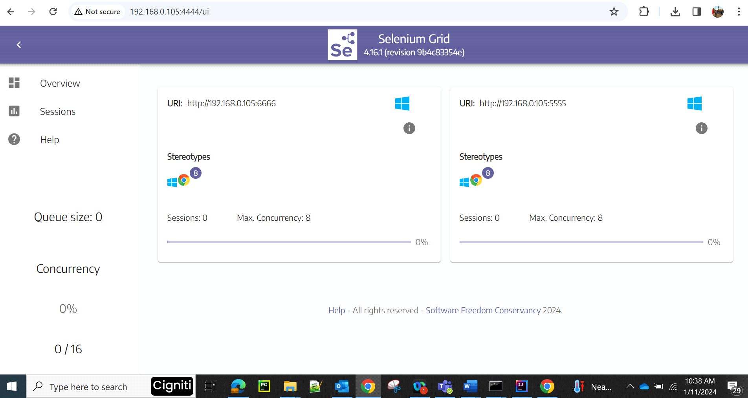

**Step4: How to trigger test on selenium grid:**

Parallel tets runs from

if (browserName.equalsIgnoreCase("Chrome")) {  
 ChromeOptions chromeOptions = new ChromeOptions();  
 chromeOptions.setCapability("platformName", "Windows");  
 chromeOptions.setCapability("se:name", "My simple test");  
 try {  
 *webDriver* = new RemoteWebDriver(new URL("http://192.168.0.105:4444"), chromeOptions);  
 } catch (MalformedURLException e) {  
 throw new RuntimeException(e);  
 }  
}

// driver = new RemoteWebDriver(new URL("http://" + username + ":" + access_key + "@hub.lambdatest.com/wd/hub"),

                capabilities);

        System.out.println("Started session");

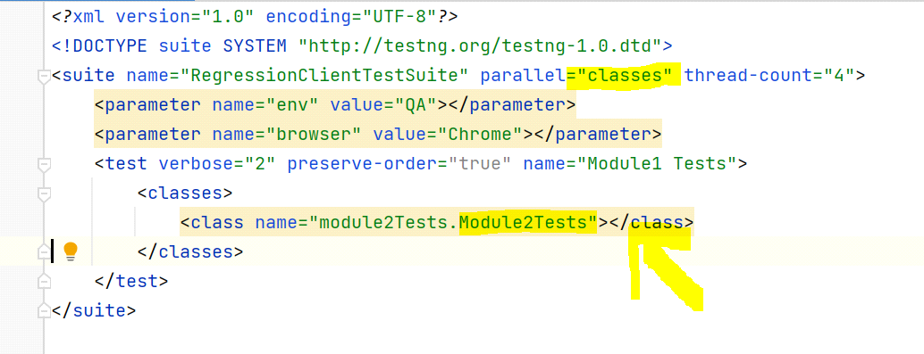

Once test execution is started on the nodes, we can see the session count on selenium grib hub GUI.

